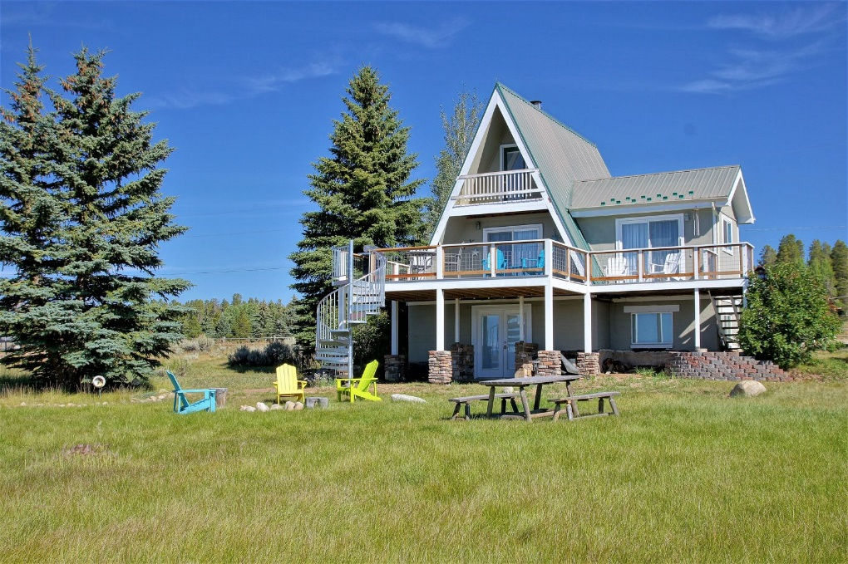

PROPERTY NAME/ADDRESS HERE

City, State, Country

WELCOME BOOK

**Welcome to our home!**

**Contact:**

**Your name here**

**+1.234.567.8901**

[**name@example.com**](mailto:name@example.com)

**Home’s Website**

**Welcome to DESTINATION!**

Give a brief overview of the property and neighborhood here. You can include a brief description of the most stand-out amenities of your house as well as anything your town is famous for. Aim to keep it short.

**About Us**

Make your guests feel at home by telling them a bit about you and your family. Make it feel personal!

Welcome to Our Home!

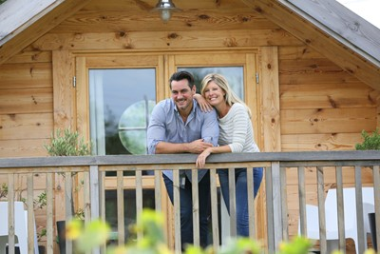

COMING AND GOING

**WIFI/INTERNET**

ID:

Password:

**Check-in/Out**

Remind your guests about the check-in/out times to avoid any confusion.

**Directions**

If your sending your welcome packet out to guests digitally before they arrive, this is a great place to include clear instructions to your home, especially if GPS is difficult to follow to your destination.

**Parking**

If there’s reserved spaces for your guests or places they definitely should NOT park, those are both good to include here.

**Check-out time**

Let your guests know what time they should de- part. Include any other departure procedures here.

EMERGENCY CONTACTS

**Here are some examples of what to include in this section:**

**Doctor/ER/Urgent Care/Pediatrician**

Include numbers and addresses

**Fire Department**

911 (or whatever emergency services responds to)

**Police Department**

Include Emergency and Non-Emergency

**Any Evacuation Locations that are Pertinent**

Include directions

TRANSPORTATION

**Here are some examples of what to include in this section:**

**Bus/Train Schedule**

Closest bus stop/route/schedule. Print out the schedule on a separate page and include here

**Airport Shuttle/Transport**

Recommend some companies, include phone number

**Local Cab Companies**

List and include phone numbers

**Information on bike shares/scooters in area**

Quick explanation of usage...

ABOUT OUR HOME

**DESCRIPTION**

Give a detailed description of your home. Could be the same description listed in your property page.

**STAFF/TIPPING PROCEDURES:**

Let your guests know if your staff requires certain fees or tips. It might also be prudent to include tipping customs for the destination if you get many international guests.

**AMENITIES**

Give detailed instructions for featured amenities including any of the following:

**Pool**

Use instructions.

**Hot Tub**

Use instructions.

**Sauna**

Use instructions.

**Game Room**

Use instructions.

**In-home theater**

Use instructions.

**Resort amenities**

Use instructions.

**Access to local Golf clubs/Country clubs/Ski Areas**

Use instructions.

APPLIANCES/FEATURES

**Here are some common appliances that often need explaining be sure to include any quirks:**

**AC/Central Heating**

Use instructions.

**Grill**

Use instructions.

**Oven/Range**

Use instructions.

**Shower/Tub**

Use instructions.

**Coffee Machine/Espresso Machine**

Use instructions.

**Fireplace**

Use instructions.

**Laundry**

Use instructions.

**Security system**

Use instructions.

**Television/Streaming system/DVD player/Sound System**

Use instructions.

**WIFI Router/Modem**

Use instructions.

**Slow Cooker/Instant Pot**

Use instructions.

GUEST CONTACTS

**Housekeeping/Maintenance**

Enter contact information here

**Security**

Enter contact information here

LOCAL ATTRACTIONS

Personal anecdotes recommended in this section!

**Weather**

Give a brief overview of the weather in your area if it can be unpredictable or unusual

**Restaurants**

Give a brief overview of your favorite local restaurants

**Local Activities**

List your favorite local hobbies and activities

**Nightlife**

Popular bars, clubs, or nighttime activities

COMMUNITY CONTACTS

**Airport**

Enter address and contact information here

**Bank**

Enter address and contact information here

**Places of Worship**

Enter address and contact information here

**Gas Stations**

Enter address and contact information here. bonus points if you include a few on the way to/from the airport

**Supermarkets**

Enter address and contact information here

**Pharmacies**

Enter address and contact information here

**PLEASE LEAVE A REVIEW**

We’d love to hear your feedback! Please leave us a review on the booking site of your choice